**XG BOOST**

**Diabetes Dataset**

I have used Xg boost on the data set of diabetes. It’s is a homogeneous ensemble method, The advantage of xg boost is that we can do parallel processing and it is the most happening algorithm in recent times, This algorithm is used to increase the accuracy and reduce the over fitting of the training data , I have tried different parameters and I have used all the processors and I have used gridsearch cv to get the best results .

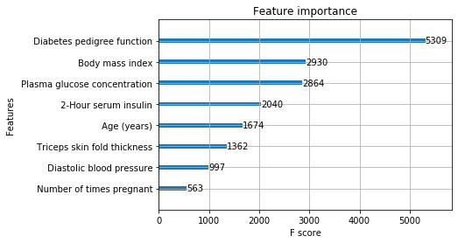

**WBCD Dataset**

I have used Xg boost on the data set of Wbcd. It’s is a homogeneous ensemble method, The advantage of xg boost is that we can do parallel processing and it is the most happening algorithm in recent times, This algorithm is used to increase the accuracy and reduce the over fitting of the training data , I have tried different parameters and I have used all the processors and I have used gridsearch cv to get the best results .

